Utilizing a grant from the New York State Department of Health, and the New York State Safe Sharps Collection Program, the Village of Marcellus has obtained disposal kiosks for unused medications and sharps, including needles, syringes, and lancets. Located in the lobby of the Village Hall, drop-off is convenient and anonymous.  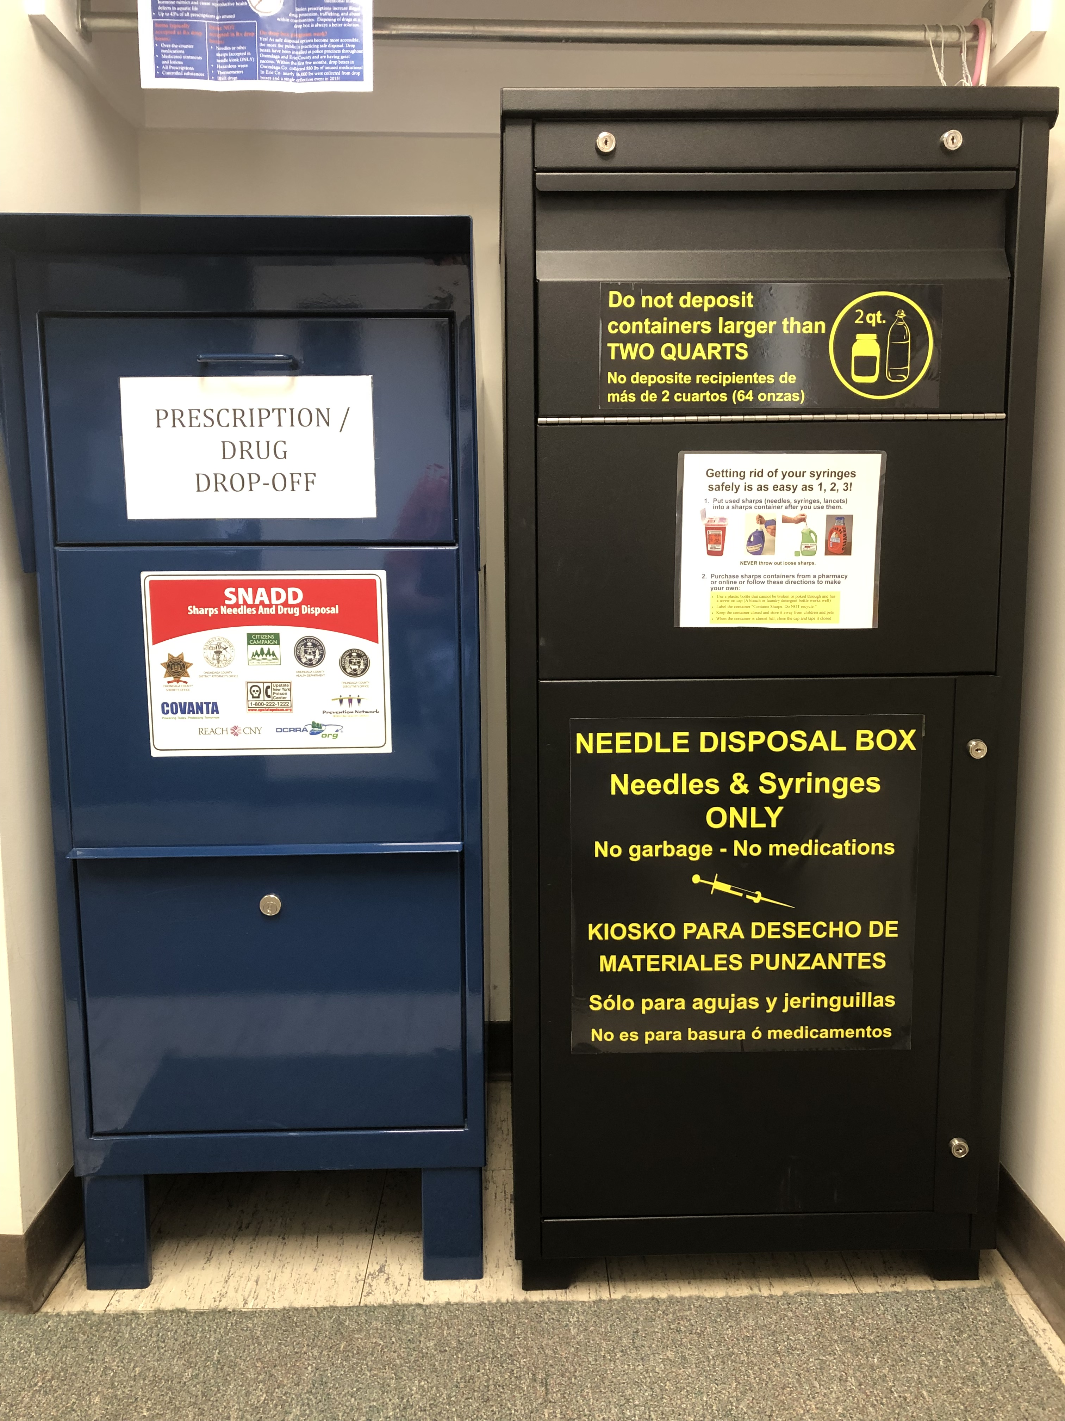 | 6 Slocombe Ave  Marcellus, ny 13108  (315) 673-3112  www.villageofmarcellus.com  Mayor John P. Curtin  Trustee Sara N. Tallman  Trustee Kevin F. O’Hara | Village of Marcellus  This Photo by Unknown Author is licensed under CC BY-NC  Safe Sharps collection program  - Easy and Safe disposal of sharps, medications and other pharmecuticals
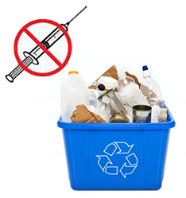  The disposal of loose sharps in the trash or with recyclables puts family members, trash haulers, recyclers, and landfill employees in danger of infection and other injuries. Do your part to keep them safe. | The Do’s and Don’ts:  - DO immediately place used needles and other sharps in a sharps disposal container to reduce the risk of needle sticks, cuts or punctures from loose sharps.  - DO use an FDA-cleared sharps disposal container or heavy duty plastic household container  - DO carry a portable sharps disposal container for travel.  - DO keep all sharps and sharps disposal containers out of reach of children and pets.  - DO seal sharps disposal containers, and label them properly  - DON’T throw loose needles and other sharps into the trash.  - DON’T flush needles and other sharps down the toilet.  - DON’T put needles and other sharps in your recycling bin -- they are not recyclable.  - DON’T try to remove, bend, break, or recap needles used by another person | 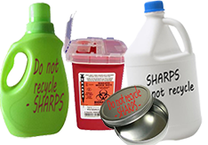  Basic Features of a Good Household Heavy-Duty Plastic Container:  - Made of a heavy-duty plastic  - Able to close with a tight-fitting, puncture-resistant lid, without sharps being able to come out, such as laundry detergent or bleach containers, a metal container with screw-on lid, or a dish soap container  - Upright and stable during use  - Leak-resistant  - Properly labeled to warn of hazardous waste inside the container.  - Water bottles, 2 Liter plastic bottles, milk jugs or other beverage containers ARE NOT puncture resistant and SHOULD NOT be used for safe sharps disposal  - Glass containers or coffee cans with snap on lids SHOULD NOT be used for safe sharp disposal

