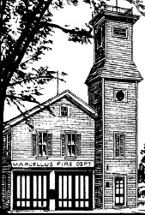

Dear Village Residents,

The Annual Meeting of the Board of Trustees will take place on April 1, 2019, and includes appointment of officials, establishing meeting dates, as well as designating official newspapers and depositories. Also, a public hearing takes place on April 1, 2019 to consider the tentative budget of the Village for the next fiscal year. Approval of the budget will take place at the regular Board meeting on April 22, 2019.

**The Budget**

The proposed General Fund budget for the Village’s fiscal year ending May 31, 2020 maintains the Village tax rate at $6.85 per $1,000 of assessed valuation for the fourth year in a row. Despite no increase in the Village tax rate, this tax levy will generate approximately $5,000 in additional revenue for the Village, due to an overall increase in the total taxable value of properties in the Village as determined by Onondaga County. This proposed Village tax levy also would not exceed the NYS Tax Cap Limit. Due to increased costs to the Village, however, the proposed budget will reflect the first full year of increased trash collection rates, from $45 to $50 per unit, which became effective January 1, 2019. The NYS Governor’s Executive Budget eliminates the Village’s allocation of State Aid to Municipalities and also freezes the Village’s allocation of State Transportation Aid at current levels. The good news is that the Village Infrastructure Program (VIP) agreement between Onondaga County and the Village has now been extended for another ten years and includes multiple increases in the amount of financial assistance to the Village. The Village greatly values the work performed by its employees, and will be offering employees a 3% raise in this new budget. Through the continuing efforts of the Village departments to operate as fiscally conservative as possible each budget year, departmental costs have been controlled. This has not only benefited the Village in offsetting the costs of unfunded mandates by NYS such as pension costs and health insurance, but in addition, it has resulted in the Village’s proposed General Fund budget showing a $22,000 budget surplus for the fiscal year ending May 31, 2020. For Village property owners, the tax rate will remain at $6.85/1000. The pie chart indicates how funds from a $685 tax on a $100,000 home will apply.

**Sewer Fund**

# ***Marcellus Village***

# ***Newsletter***

***Volume 24***

# ***Issue 1***

# ***Spring 2019***

***------------***

# 315.673.3112

# marboard@twcny.rr.com

**315.673.3112**

[**marboard@twcny.rr.com**](mailto:marboard@twcny.rr.com)

## Newsletter

**Volume 8**

#### Issue 1

### January 2003

The very costly upgrades to the Village’s Wastewater Treatment Plant, as mandated from NYSDEC, to the tune of almost $8 million, are well underway. As such, during the fiscal year, ending May 31, 2020, the $5.2 million interest free construction loan received from the NYS Environmental Facilities Corporation (EFC) is scheduled to enter its repayment period. This repayment period will last for 30 years, at an annual cost to the consolidated sewer system users in the Village Town and School District over $173,000. Consequently, the Village is left no choice but to increase the minimum sewer rate per unit from $75 to $100 (a 33% increase), reflected in the April 1, 2019 billing. All of this additional sewer usage revenue will serve to build up the Village’s Unappropriated Sewer Fund Balance for the sole purpose of paying for these upgrades over the next 30 years. Based on this, the Village’s proposed Sewer Fund budget shows a $62,000 budget surplus for the fiscal year ending May 31, 2020.

**Increase In Sewer Rates**

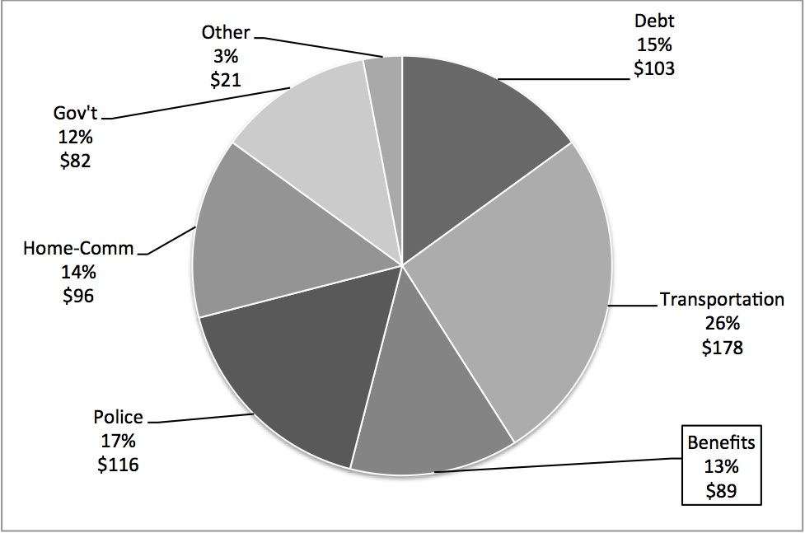In trying to offset excessive sewer rates, the Village has been successful in securing some funding, including several WQIP awards of $80,000 and $1,000,000, and a EPG grant of $30,000, as well as zero (0%) percent financing from the Environmental Financing Corporation, and it is hoped that additional funding can be secured to help meet the DEC mandate. A potential SAM grant of $250,000 is pending, as are others. However, the plant upgrade is now almost $8 million, bids have been awarded, and construction has begun, with a scheduled completion date of late August, 2019. Funding can only come from sewer rate increases and as mentioned at previous meetings, we found it necessary to approve another sewer rent increase of approximately 33% at our December Board meeting. This will mean a minimum quarterly sewer rate, for Village sewer users, of $100.00 (from $75.00) and a minimum annual cost of $400 (from $300) and an average annual cost of about $548 (from $415). Keep in mind that this is an **average estimate**, since sewer rates are based on water usage in the Village. The annual cost for outside users (Town and School District) is anticipated to be $686 (from $516), given that outside users pay an additional 25% over that of the average Village sewer user – an increase of about $160.00 per year, beginning in 2020. In order to prepare our Plant for operation into the 21st century, these increases, while hefty, are unavoidable.

**New Business in the Village – Grand Opening – Summer of 2019**

Look for an early summer opening of a new business in the Village at 4 E. Main St. called *Gretchen’s Confections*, specializing in handcrafted chocolates, baked goods, coffees and soups. It will offer a chocolate shop and café, and also feature a production kitchen. We welcome this new Village business, a long vacant site on Main Street.

**Property Tax Cap**

The property tax cap of 2%, another State mandate, complicates our budget and at its March meeting, the Board overrode the tax cap. We expect to stay under the property tax cap but the cap compounds the process and we might not be able to abide by the State’s tax cap formula. Having learned from the experience of several towns, it is best to override, if only to protect the Village from penalty.

**Social Media Policy**

A new social media policy for the Village of Marcellus has been developed by Village Clerk Charnley Abbott, with the endorsement of Village Attorney, Jeff Brown. This policy will enable the Village to make public information more readily available, to inform residents and visitors about government services and local attractions, and to further enhance the Village’s messaging and news delivery systems. A copy of the policy is available for public inspection in the Village Office. Also, please check out the Village of Marcellus on Facebook.

**Board Appointments**

At its Annual Meeting, the Village Board will re-appoint Theresa LaMarre to another 5-year term as a member of the Village Planning Board – from April 1, 2019 to March 31, 2024. The Board will also approve the two-year appointment of Richelle Schettine as an alternate member of the Planning Board – from April 1, 2019 to March 31, 2021. In addition, the Village Board will reappoint Jeff Averill to another 5-year term as a member of the Zoning Board of Appeals – from April 1, 2019 to March 31, 2024. We are very grateful to Theresa, Richelle and Jeff for their willingness to serve, without compensation, on these Boards.

**Trash Transfer Site**

The trash transfer site for Village and Town residents will begin on April 26th and April 27th, with additional dates on May 3rd and May 4th and May 10th and May 11th. The fee schedule remains the same as last year. A permit is required and obtained at the Town office. Tires as well as items with Freon, such as refrigerators, air conditioners or dehumidifiers require an additional fee. Some items are not accepted including garbage, recyclables, hazardous waste, and contractor debris. There will also be an Electronics Waste Disposal with trash days this year, which will require a special fee, as well as a shred day. There will be no cost to the residents for the shredding.

**Clean Energy Community**

 As mentioned at earlier Board meetings, a $100,000 grant has been secured for the Village of Marcellus to implement clean energy projects. This has involved a retrofitting of several existing Village lights to direct wire LED type fixtures, as well as other LED lighting retrofits in the Village Hall and Garage and Treatment Plant. We also have added six (6) new historic lampposts, with LED type fixtures, to several streets in the Village with a goal of installing two (2) additional historic lights. In addition, we are working with NYSEG to convert all of the remaining overhead lights in the Village from HPS bulbs to LED bulbs. The average annual savings for the Village as a result of the project is estimated to be in excess of $20,000.

**Creek Walk**

*Fred’s Trail* will reopen for the pubic when the snow finally leaves the trail. At first glance, it appears that the winter weather has not caused much damage to the trail. Some hardy people braved the elements to walk the trail this winter, although it was not officially open.



**Clean The Village For Earth Day**

The Village of Marcellus will again participate in an Earth Day Clean Up on Thursday, April 25, 2019. 4th graders from KCH Elementary School will participate in this event and we welcome any individuals or groups to join us in helping clean the Village of litter lying along the roadsides. If interested in participating, we will meet in front of the Village Hall (about 1:30 p.m.) to distribute bags and gloves

**Brush Pick-up**

With the arrival of spring and a need to clean up before Memorial Day and Olde Home Days, brush pick-up will start soon. With Board’s approval, the DPW is going to continue a policy initiated in 2018. Brush may be placed at the curb on Saturdays and Sundays for pickup on Mondays from April 1st to May 6th. Also, during summer months (June, July and August), brush may be placed at the curb on Saturdays and Sundays for pickup on the first Monday of each month during those summer months.

**Police and School Safety**

On March 18th, the Marcellus School District held a professional development day and the day called for Chief of Police Wicks and his team to present CRASE training, a type of training designed as a precursor to doing an active shooter drill as well as provide participants with information to assist in thinking through their responses in a crisis situation. A full day training program, this initiative by Chief Wicks and the MPD highlighted how well prepared Marcellus SROs are to handle threats against the school. The role of Chief Wicks in establishing a School Resource Officer Program at the MCS is especially noteworthy. Now ten years old, the SRO Program at MCS has enjoyed unparalleled success and is touted as one of the finest in Onondaga County, if not the State of New York.

##### Olde Home Days

"Olde Home Days 2019" is planned for May 31st, June 1st, and 2nd in the Village and in Marcellus Park, and honoring Olde Home Days Leadership, from 1995-2019. We congratulate Cathy Marsden and John Curtin who will be Grand Marshals of the Olde Home Days Parade on June 1st. A fun filled weekend is planned.

**Utility Bills**

The utility bill that residents receive this month is the last bill for our fiscal year. Please note that if a resident’s bill is not paid by April 30, 2019, it will be re-levied to the tax bill for June 1, 2019. If those bills for tenants who pay their own utilities are not paid by April 30, 2019, these too will be re-levied onto the owner's taxes for June 1, 2019.

**Notice of Sign Placement**

Soon, the Highway Department will re-install pedestrian crossing signs on Main Street in the Village. The signs are placed in the road, near the crosswalks, warning motorists that all vehicles must yield to pedestrians who are walking in the crosswalk – a New York State law.

**Some Reminders**

The Village Office is closed on Good Friday, April 19th and will be closed on Memorial Day, May 27th. There will be a one-day delay for trash collection because of Memorial Day. Thank you for taking the time to read this letter and we hope you enjoy a beautiful spring and summer.

John P. Curtin, Mayor

Sara N. Tallman, Trustee

Kevin F. O’Hara, Trustee

Charnley A. Abbott, Clerk

Nino J. Provvidenti, Treasurer

Jeffrey D. Brown, Attorney