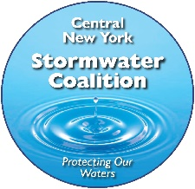
The Village of Marcellus is a long-standing member of the CNY Stormwater Coalition, a 30-member intermunicipal organization that is committed to water quality improvement and protection.
The CNY Stormwater Coalition believes that everyone has a role in keeping our surface waters clean and healthy. As an organization, we are committed to providing information that supports water protection through informed personal choices. To be effective, we need to hear from you. Please take a few minutes to complete our online survey. Your responses will help us deliver useful and interesting information in a format that meets your lifestyle and addresses your interests. The survey takes approximately 5 minutes to complete but will help us shape our education program for years to come. Thank you in advance for participating in our survey. Click HERE to participate in the survey.

